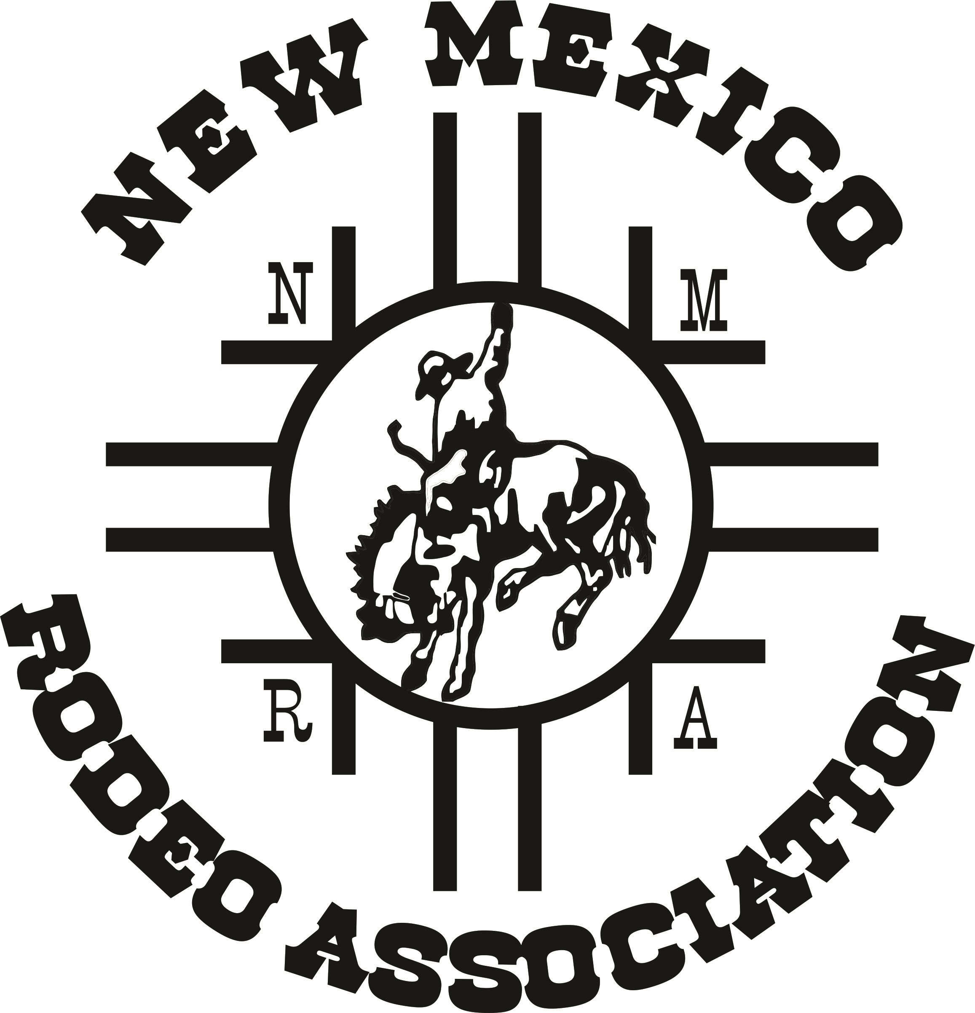

New Mexico Rodeo Association
PO Box 1101
Capitan, NM 88316
Office/Mobile: (575) 937-0851
Fax: (575) 258-2164
Email: nmrastateoffice@gmail.com
Website: www.nmrodeo.org

NMRA 2016 Stock Contractors:

W/A Rodeo Company
Buster Webb
PO Box 383
Bloomfield, NM 87413
505-632-2350

6 X 6 Rodeo Company
Donnie Bradley
PO Box 110
Tres Piedras, NM 87577
575-758-3459

Tsosie Brothers Rodeo Company
Harrison or Tommie Tsosie
PO Box 1950
Shiprock, NM 87420
505-368-4315

Bucking H Rodeo Company
Richard Hodgson
9355 Hwy 64
Blanco, NM 87412

Baca Rodeo Company
Casper Baca
PO Box 1715
Grants, NM 87020
505-287-9534

Frontier Rodeo Company
Gary or GT Nunn
PO Box 1472
Belen, NM 87002
505-450-6724

