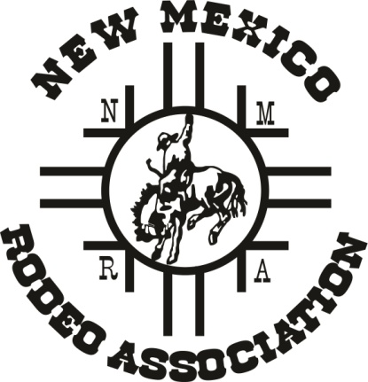
NEW MEXICO
RODEO ASSOCIATION

HC 66 Box 128
Mountainair, NM 87036
505-366-4929
nmrastateoffice@gmail.com
www.newmexicorodeoassociation.org

In 1980 the NMRA was established and is the oldest rodeo association in New Mexico that brings together over 400 cowboys and cowgirls from NM, AZ, CO, TX, UT and OK.
The NMRA is a non-profit organization dedicated to preserving and improving the sport of rodeo. The NMRA is proud to say that our primary reason for existence provides a fun and traditional way for families to compete or spectate together. The NMRA relies solely on contributions from individuals and business to fund our award program and Finals Rodeo each year. Your support is extremely important to us! Donations are 100% tax deductible. (NMSPRC # is 1052133 & our 501 (c) 3 # is 85-0336784)
Thank you for your support,
NMRA Board of Directors

Sponsor Name/Business: _______________________________________________

Address: ____________________________________________________________

Phone:____________________________ email: ____________________________

Please make check payable to: NMRA

Please support the rodeo organization in one of the following amounts:

______ $ 1,500 Event Sponsor ______$1,200 Saddle Sponsor

______ $ 500 Event Champion ______ $250 Finals Rodeo Event
Buckle Sponsor Buckle Sponsor

______ $ 100 Jacket Sponsor ______ Other- Any amount is appreciated

