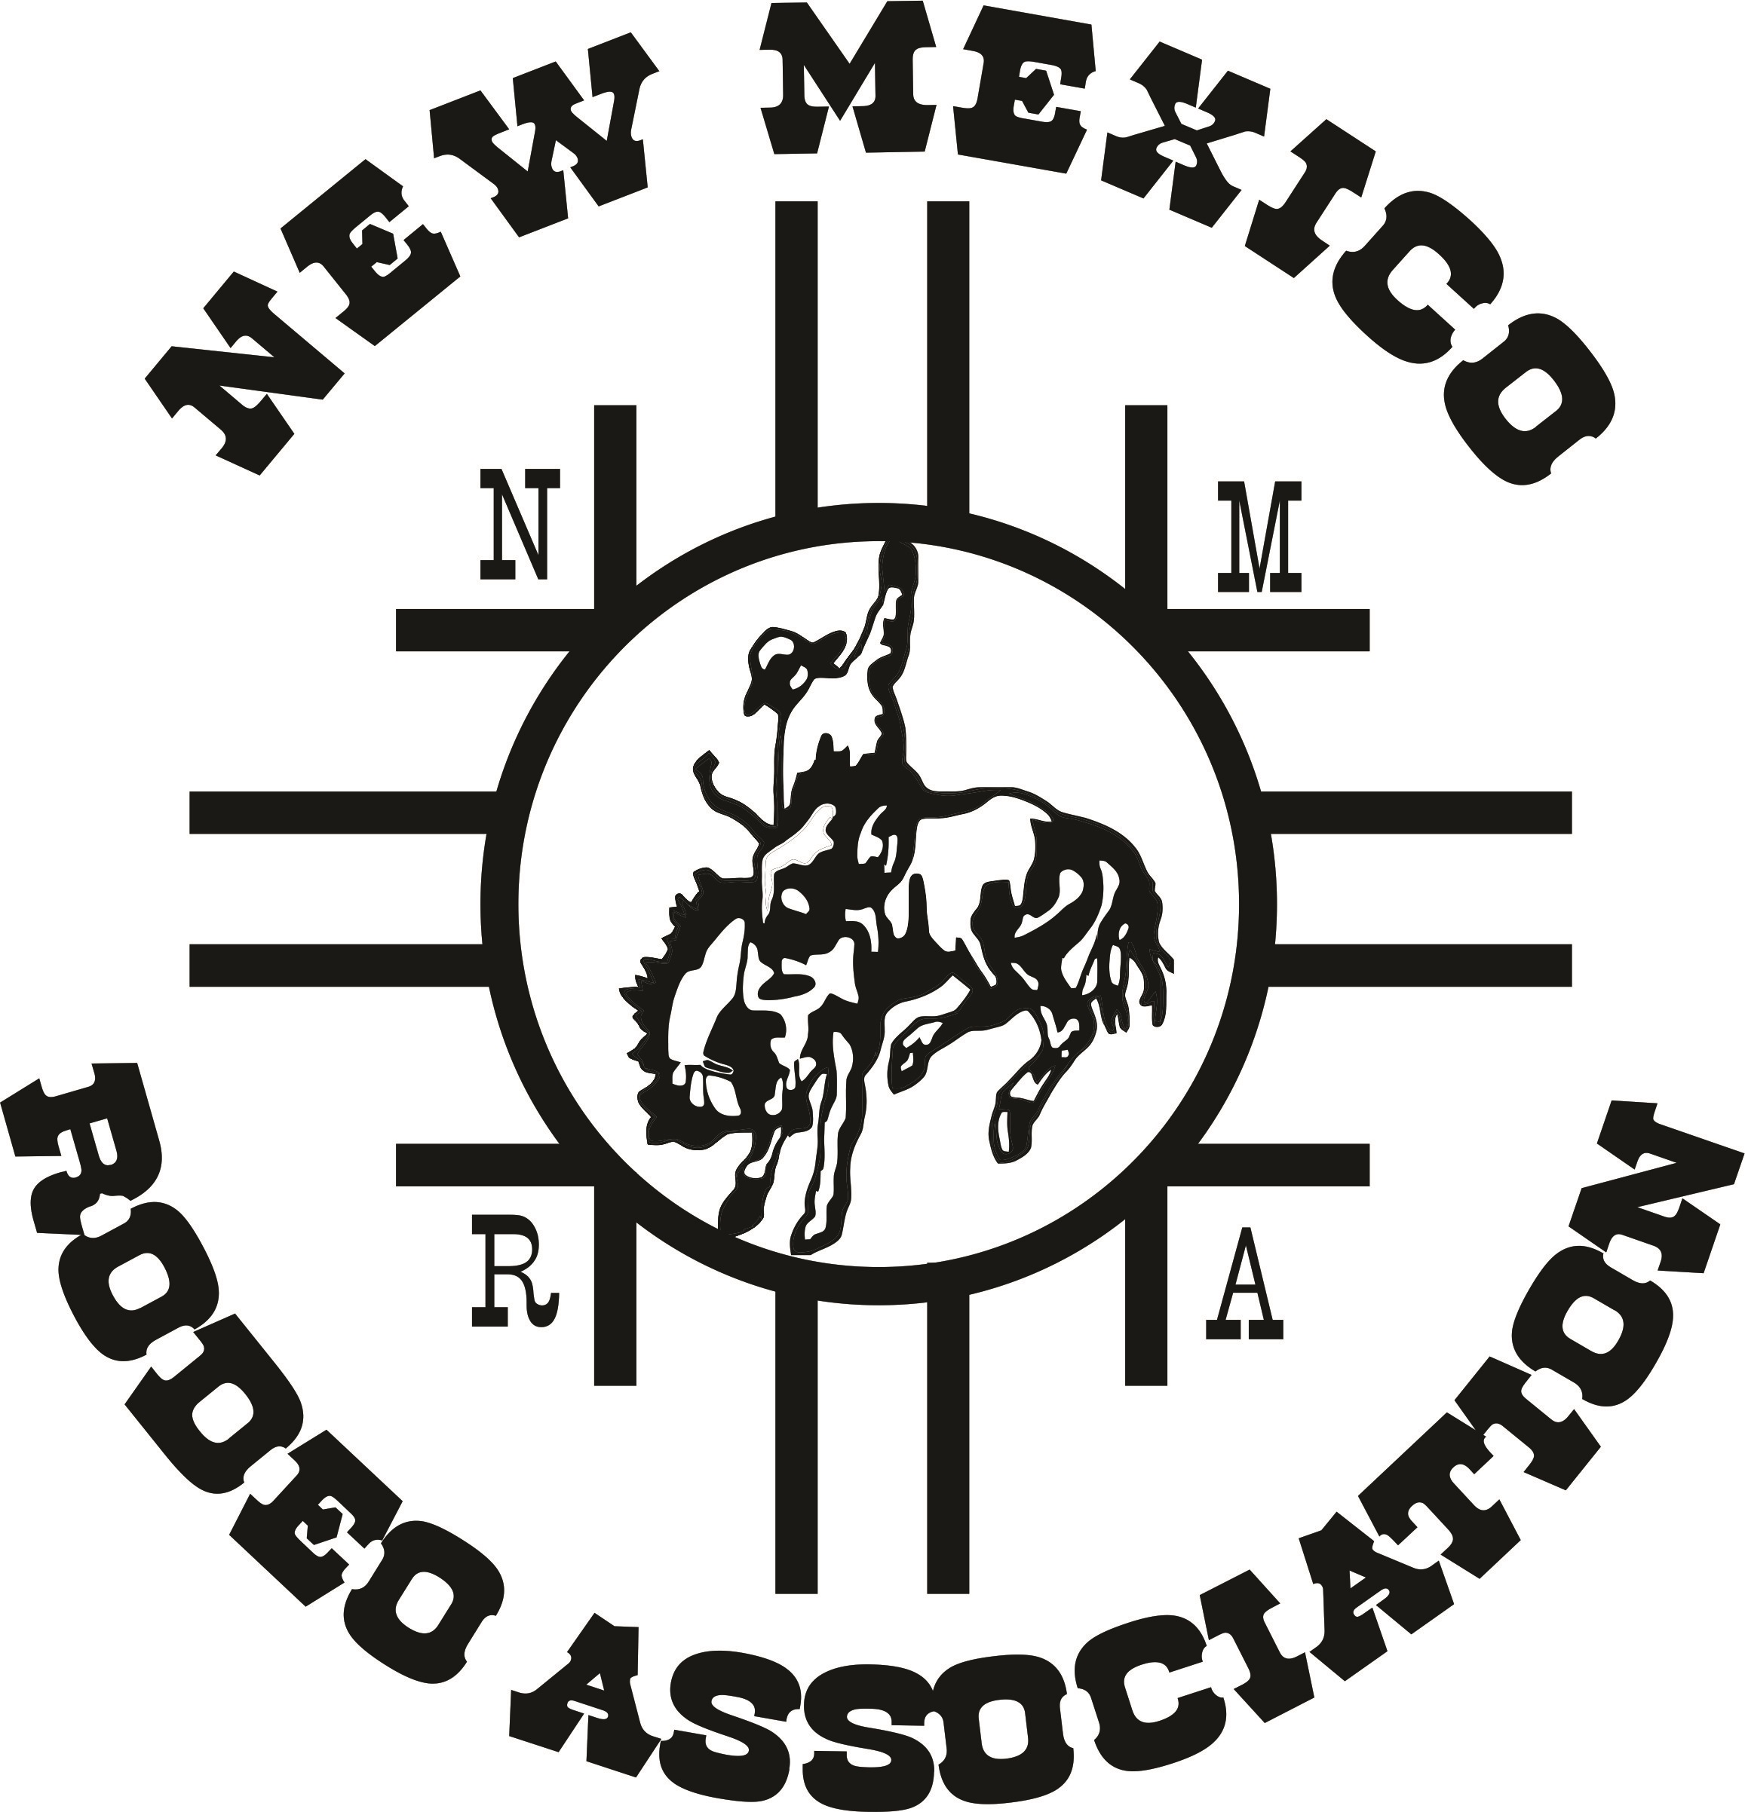
New Mexico Rodeo Association Sanction
Sheet & Contract
Mail to: 2107 CR 3270
Mineola, TX 75773

Phone – (505) 366-4929
Email – nmrastateoffice@gmail.com
Name of Rodeo: _______________________________________________________ City: ________________________________
Arena name & one sentence location: ____________________________________________________________________________
___________________________________________________________________________________________________________
Stock Contractor: ________________________________________ Co-Sanctions requested: _______________________________

Dates and Times of each Performance and/or slack:
_________________________________________________ __________________________________________________
_________________________________________________ __________________________________________________
_________________________________________________ __________________________________________________
_________________________________________________ __________________________________________________
Notice: Non-members not within a 50 mile radius also have a $15 added fee.

EVENTS ENTRY FEE ADDED/PRIZES NOTES/RULES

Bareback (BB) __$100______ ______________ _____________________________

Saddle Bronc (SB) __$100 ______________ _____________________________

Ranch Bronc Riding (RBR) __$80_______ ______________ _____________________________
(optional & optional added money)
Bull Riding (BR) __$100_____ ______________ _____________________________

Novice Bull Riding (NBR) __$80 ______________ _____________________________
(optional & optional added money)
Tie Down Roping (TD) __$120_____ ______________ _____________________________
(With Incentive TD)
Steer Wrestling (SW) __$120_____ ______________ _____________________________

Ladies Breakaway (BKWY) __$120______ ______________ _____________________________

Ladies Barrel Race (BRLS) __ $90 _____ _______________ _____________________________
(With Incentive Barrels)
Team Roping (TR) __$120_______ _______________ _____________________________

#10 Team Roping (ITR) __$120______ _______________ _____________________________
(Include extra page if necessary)

Central Entry Date: _____________________ CES: 505-864-9426 (entries)
CES Entry Times: 6:00 PM – 9 PM Monday before the rodeo (typically) Stock Charge: $20.00
CES take Local Entries In Advance: Yes ___ No ___ If yes please contact CES 505-864-9426 to coordinate a time and location.

Committee Contacts – IMPORTANT please let us know if these change at any time during the year.

Name: ______________________________________ Name: _____________________________________
Address: ______________________________________ Address: _____________________________________
City/State/Zip:___________________________________ City/State/Zip:_________________________________
Phone: ______________________________________ Phone: _____________________________________
Email: ______________________________________ Email: _____________________________________

New Mexico Rodeo Association Sanction Contract

Committee/Rodeo _____________________________________________________ agrees to the following:

1. The Central Entry System (CES) will take entries, work with the Stock Contractor on entry day, coordinate the process and integrate local entries if any, and get the day sheets to you for your program. The entries will be open from 6:00 PM to 9:00 PM on the Monday (usually) before your rodeo. CES number for entries only: Timed Events 505-864-9426; Rough Stock 505-864-9427 and Team Roping

2. Local entry guidelines must be followed if local entries are taken. If you request local entries, we will help you. This does not, however, take place of Central Entry.

3. A $125 sanction fee is required to approve the rodeo, to be paid upon submission of this contract. The fee is reduced to $100 if the contract is in the NMRA office by April 1, 2024.

4. A minimum of $300 will be added to each event. Any rodeo committee wishing to provide buckles to event champions must provide a buckle for all standard NMRA events and may then be allowed to add $200 plus buckles to each standard event. All added monies &/or prizes must be furnished to the field secretary at the committees earliest opportunity or at the discretion of the field secretary. Added money is to be in cash.
- The NMRA is willing to work with any rodeo committee wishing to add less than the minimum added money requirement – just contact us!!

5. The NMRA personnel will enforce rules during all performances and slack. Members, Rodeo Committees and Stock Contractors are required to abide by the rulebook, with any infractions being presented in writing before the Board of Directors for disciplinary action.

6. All NMRA sanctioned rodeos will have no limited entries.

7. The NMRA will provide a qualified Arena Secretary and will pay for one approved judge. The Stock Contractor must pay for the additional approved judge for the rodeo. The secretary will handle all the books and payout for your rodeo and help the judges and stock contractor enforce the rules. Secretaries and judges will work with the Rodeo Committee in order to keep the rodeo running smoothly. The secretary will need a list of your officers and/or committee members (important).

8. An ambulance and arena dragging equipment shall be provided by the Committee and present at all performances and slack. Qualified Rodeo Timers for rodeo will also be provided by the Committee/Stock Contractor.

9. The rodeo will be advertised in our official publication, “The Rodeo News”, and on our website, www.newmexicorodeoassociation.org at no charge to you from the time this contract is received in our office until the rodeo takes place. It is to the committee’s advantage to get this contract in to the NMRA as early as possible to maximize advertising.

10. Any official sponsors of the NMRA shall be allowed to display advertising material and have airtime (one instance) through the public address system at the rodeo. This is typically a flag or banner with an appropriate announcement, and will be tasteful and professional.

11. The Committee must provide proof of spectator liability insurance, which does relieve the NMRA and Stock Contractor of any liability and responsibility.

12. Current entry fees are listed above on page 1 of contract. Any rodeo that adds a minimum of $500 per event will have the option of setting the entry fees within reason and with the President’s approval. Please note on the sanction sheet the request for entry fees to be.

13. There will be an $10 finals fund fee deducted from all contestant’s entry fees. (No exceptions).

14. There shall be a $15 non-member charge to all non-members entering the rodeo. Local contestants (living within a 50 mile radius) will not be assessed this fee.

15. Any NMRA member entered in the rodeo shall be admitted free to all performances and slack unless other arrangements have been made. Member must show their 2024 NMRA card.

16. Special Requests: All special requests must be approved by board of directors and must be within the NMRA rules.

Please refer to NMRA Current Rulebook for further information. Rulebook located on NMRA website at www.newmexicorodeoassociation.org.

Requested Secretary: ___________________________________________________________________

Requested Judges: ______________________________________________________________________

Ground Rules: __________________________________________________________________________
(Leave blank if no requests)
(Due to scheduling conflicts, etc, the NMRA cannot guarantee that these request will be met).

Signed: ______________________________________________________________________________

Title: ______________________________________________________________________________

Date: ______________________________________________________________________________

Please fill out all information and remit all 3 pages with sanction fee to the following address, no later than 60 days before your event so that sufficient time is given for co-sanction requests and advertising.

NEW MEXICO RODEO ASSOCIATION
Contact Information:
Janice Aragon – State Secretary State Office: (505) 366-4929
2107 CR 3270
Mineola, TX 75773 Email- nmrastateoffice@gmail.com

Central Entry Secretary – Amber Gillreath
Central Entry: (505) 864-9426
Turn Out Line: (505) 864-9426
nmraentryoffice@gmail.com

